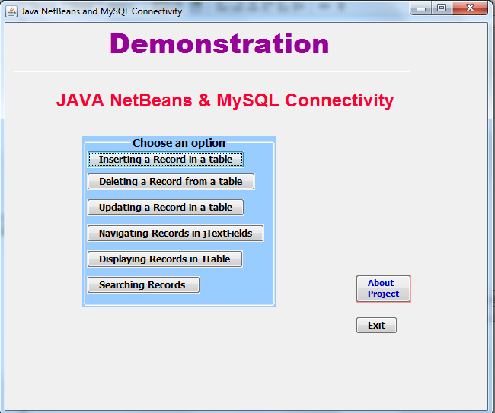
MainUI.java

public class MainUI extends javax.swing.JFrame {
public MainUI() {
initComponents();
}
private void jButton1ActionPerformed(java.awt.event.ActionEvent evt) {
AboutMe.setVisible(false);
}
private void jButton2ActionPerformed(java.awt.event.ActionEvent evt) {
new EmpAddUI().setVisible(true);
new EmpAddUI().getAlignmentX();
}

private void jButton3ActionPerformed(java.awt.event.ActionEvent evt) {
new EmpDelUI().setVisible(true);
}

private void jButton4ActionPerformed(java.awt.event.ActionEvent evt) {
new EmpEditUI().setVisible(true);
}
private void jButton5ActionPerformed(java.awt.event.ActionEvent evt) {
System.exit(0);
}
private void jButton6ActionPerformed(java.awt.event.ActionEvent evt) {
AboutMe.setVisible(true);
}
private void jButton7ActionPerformed(java.awt.event.ActionEvent evt) {
new EmpNavUI().setVisible(true);
}
private void jButton9ActionPerformed(java.awt.event.ActionEvent evt) {
new EmpSearchUI().setVisible(true);
}
private void jButton8ActionPerformed(java.awt.event.ActionEvent evt) {
new EmpTable().setVisible(true);
}
public static void main(String args[]) {
java.awt.EventQueue.invokeLater(new Runnable() {
public void run() {
new MainUI().setVisible(true);

}
});
}
// Variables declaration - do not modify
private javax.swing.JDialog AboutMe;
private javax.swing.JButton jButton1;
private javax.swing.JButton jButton2;
private javax.swing.JButton jButton3;
private javax.swing.JButton jButton4;
private javax.swing.JButton jButton5;
private javax.swing.JButton jButton6;
private javax.swing.JButton jButton7;
private javax.swing.JButton jButton8;
private javax.swing.JButton jButton9;
private javax.swing.JLabel jLabel1;
private javax.swing.JLabel jLabel10;
private javax.swing.JLabel jLabel11;
private javax.swing.JLabel jLabel12;
private javax.swing.JLabel jLabel13;
private javax.swing.JLabel jLabel14;
private javax.swing.JLabel jLabel2;
private javax.swing.JLabel jLabel4;
private javax.swing.JLabel jLabel5;
private javax.swing.JLabel jLabel6;
private javax.swing.JLabel jLabel7;
private javax.swing.JLabel jLabel8;
private javax.swing.JLabel jLabel9;
private javax.swing.JPanel jPanel1;
private javax.swing.JSeparator jSeparator1;
// End of variables declaration

}

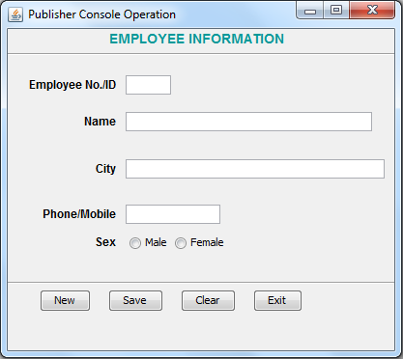
EmpAddUI.java
import java.sql.*;
import javax.swing.JOptionPane;
public class EmpAddUI extends javax.swing.JFrame {
public EmpAddUI() {
initComponents();
}
private void cmdExitActionPerformed(java.awt.event.ActionEvent evt) {
this.setVisible(false);
new MainUI().setVisible(true);
}

private void formWindowGainedFocus(java.awt.event.WindowEvent evt) {
txtNo.setEditable(false);

// Deactivate the Save button when form loads
cmdSave.setEnabled(false);
}

private void cmdNewActionPerformed(java.awt.event.ActionEvent evt) {
// Activate the Save button when New button clicked
cmdSave.setEnabled(true);
try {
Class.forName("com.mysql.jdbc.Driver");
Connection con = (Connection)
DriverManager.getConnection("jdbc:mysql://localhost:3306/test","root","raj");
Statement stmt = null;
ResultSet rs = null; // ResultSet for publisher table.
String SQL = "SELECT * FROM emp";
stmt = con.createStatement(); // Connection string for ResultSet - rs.
rs = stmt.executeQuery(SQL);
int pno = 1;
int PID=0;
while (rs.next()) {
PID = rs.getInt("empid");
pno++;
}
PID++;
pno = PID;
txtNo.setText(Integer.toString(pno));
txtPName.setFocusable(true);
con.close();
rs.close();
stmt.close();
} catch (Exception e) {
JOptionPane.showMessageDialog(this,e.getMessage());
e.printStackTrace();
}
}
private void cmdSaveActionPerformed(java.awt.event.ActionEvent evt) {
try {
Class.forName("com.mysql.jdbc.Driver");
Connection con = (Connection)
DriverManager.getConnection("jdbc:mysql://localhost:3306/test","root","raj");
Statement stmt = null;
ResultSet rs = null;
String SQL = "SELECT * FROM emp";
stmt = con.createStatement();
rs = stmt.executeQuery(SQL);
int no = Integer.parseInt(txtNo.getText());
String nam = txtPName.getText();
String city = txtCity.getText();
String ph = txtPhone.getText();
char sex='Y';
if (jRadioButton1.isSelected())
sex = 'M';
else
sex='F';
int code = JOptionPane.showConfirmDialog(this, "Are you sure to add?", "Confirmation Dialog Box", JOptionPane.YES_NO_CANCEL_OPTION, JOptionPane.INFORMATION_MESSAGE);
if (code == JOptionPane.YES_OPTION) {
String strSQL = "INSERT INTO emp(empID, EmpName, EmpCity, EmpPhone, EmpSex) VALUES ("+(no)+", '"+(nam)+"', '"+(city)+"', '"+(ph)+"', '"+(sex)+"')";
stmt.executeUpdate(strSQL);
JOptionPane.showMessageDialog(this, "Record added successfully into Employee table");
}
con.close();
stmt.close();
rs.close();
cmdSave.setEnabled(false);
} catch (Exception e) {
JOptionPane.showMessageDialog(this, e.getMessage());
}

}

private void cmdClearActionPerformed(java.awt.event.ActionEvent evt) {
txtNo.setText("");
txtPName.setText("");
txtCity.setText("");
txtPhone.setText("");
cmdSave.setEnabled(false);
}
// Variables declaration - do not modify
private javax.swing.ButtonGroup buttonGroup1;
private javax.swing.JButton cmdClear;
private javax.swing.JButton cmdExit;
private javax.swing.JButton cmdNew;
private javax.swing.JButton cmdSave;
private javax.swing.JLabel jLabel1;
private javax.swing.JLabel jLabel2;
private javax.swing.JLabel jLabel3;
private javax.swing.JLabel jLabel4;
private javax.swing.JLabel jLabel5;
private javax.swing.JLabel jLabel6;
private javax.swing.JRadioButton jRadioButton1;
private javax.swing.JRadioButton jRadioButton2;
private javax.swing.JSeparator jSeparator1;
private javax.swing.JSeparator jSeparator2;
private javax.swing.JTextField txtCity;
private javax.swing.JTextField txtNo;
private javax.swing.JTextField txtPName;
private javax.swing.JTextField txtPhone;
// End of variables declaration
}

EmpDelUI.java
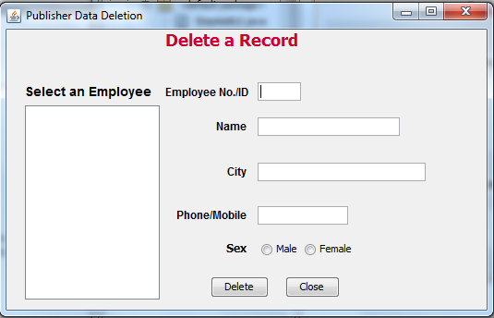

import java.sql.*;
import javax.swing.JOptionPane;
import javax.swing.DefaultListModel;

public class EmpDelUI extends javax.swing.JFrame {

public EmpDelUI() {
initComponents();
}
Statement stmt = null;
ResultSet rs = null;
String SQL = "SELECT * FROM emp";

private void cmdDeleteActionPerformed(java.awt.event.ActionEvent evt) {
try {
Class.forName("com.mysql.jdbc.Driver");
Connection con = (Connection)
DriverManager.getConnection("jdbc:mysql://localhost:3306/test","root","raj");
stmt = con.createStatement();
rs = stmt.executeQuery(SQL);
int pno = Integer.parseInt(txtNo.getText().trim());
// Steps to confirm deletion
int opt = JOptionPane.showConfirmDialog(null, "Are you sure to delete this record ?");
if (opt == JOptionPane.YES_OPTION)
{
try {
String strSQL = "Delete from emp where empId = " + (pno);
int rowsEffected = stmt.executeUpdate(strSQL);
if (rowsEffected == 0)
JOptionPane.showMessageDialog(this, "Record does not exists");
else
{
JOptionPane.showMessageDialog(this,"Record Deleted");
// Text boxes cleared
txtNo.setText("");
txtName.setText("");
txtAdd.setText("");
txtPhone.setText("");
txtNo.setEditable(true);
}
} catch (Exception e) {
JOptionPane.showMessageDialog(null, "Unable to delete");
}
}
} catch (Exception e) {
JOptionPane.showMessageDialog(this, e.getMessage());
}
}

private void cmdExitActionPerformed(java.awt.event.ActionEvent evt) {
this.setVisible(false);
//new MainUI().setVisible(true);
}
private void jList1MouseClicked(java.awt.event.MouseEvent evt) {
// getSelectedValue() method extracts the current cursor location value into a variable
String st = (String) jList1.getSelectedValue();
// Extract the first 4 characters as roll number into a variable
String Id =st.trim().substring(0, 3);
String query = "SELECT * FROM emp WHERE empId = " + Id + ";";
try {
Class.forName("com.mysql.jdbc.Driver").newInstance();
Connection con = (Connection) DriverMnager.getConnection("jdbc:mysql://localhost:3306/test","root","raj");
// Create SQL statement and execute query.
stmt = con.createStatement();
rs = stmt.executeQuery(query);
if (rs.next()) {
String MName = rs.getString("empName");
String MCity = rs.getString("empCity");
String MPh = rs.getString("EmpPhone");
String MSex = rs.getString("EmpSex");
// Displaying the contents in respective text boxes.
txtNo.setText(Id);
txtName.setText(MName);
txtAdd.setText(MCity);
txtPhone.setText(MPh);
if (MSex.equals("M"))
jRadioButton1.setSelected(true);
else
jRadioButton2.setSelected(true);
txtNo.setEditable(false);
} else {
JOptionPane.showMessageDialog(null, "Record does not found in Student table");
}
} catch (Exception e) {
JOptionPane.showMessageDialog(this, e.getMessage());
}
}
private void formWindowGainedFocus(java.awt.event.WindowEvent evt) {
txtNo.setEditable(false);
// Creating a ListModel object dModel to perform DefaultListModel
DefaultListModel dModel = (DefaultListModel) jList1.getModel();
// Method to add elements into jList1 control
dModel.clear();
try {
Class.forName("com.mysql.jdbc.Driver");
Connection con = (Connection)
DriverManager.getConnection("jdbc:mysql://localhost:3306/test","root","raj");
stmt = con.createStatement();
rs = stmt.executeQuery(SQL);
while (rs.next()) {
String Pno = rs.getString("empId");
String PName = rs.getString("empName");
// To make the publisher no. as 4 digit because we will extract 4 digit from list value
// in mouse click event.
if (Pno.length() < 4)
{
int x = Pno.length();
int nl = 4 - x;
while (nl > 0){
Pno = Pno + " ";
nl--;
}
}
dModel.addElement(Pno + "- " + PName);
}
jList1.setModel(dModel);
con.close();
} catch (Exception e) {
JOptionPane.showMessageDialog(this,e.getMessage());
e.printStackTrace();
}
}

// Variables declaration - do not modify
private javax.swing.ButtonGroup buttonGroup1;
private javax.swing.JButton cmdDelete;
private javax.swing.JButton cmdExit;
private javax.swing.JLabel jLabel1;
private javax.swing.JLabel jLabel2;
private javax.swing.JLabel jLabel3;
private javax.swing.JLabel jLabel4;
private javax.swing.JLabel jLabel5;
private javax.swing.JLabel jLabel6;
private javax.swing.JLabel jLabel7;
private javax.swing.JList jList1;
private javax.swing.JRadioButton jRadioButton1;
private javax.swing.JRadioButton jRadioButton2;
private javax.swing.JScrollPane jScrollPane1;
private javax.swing.JTextField txtAdd;
private javax.swing.JTextField txtName;
private javax.swing.JTextField txtNo;
private javax.swing.JTextField txtPhone;
// End of variables declaration

}
EmpEditUI.java

import java.sql.*;
import javax.swing.JOptionPane;
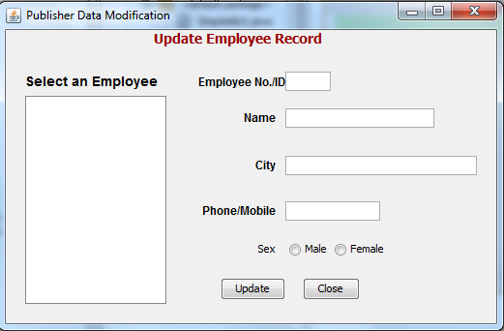
import javax.swing.DefaultListModel;

public class EmpEditUI extends javax.swing.JFrame {
public EmpEditUI() {
initComponents();
}

private void formWindowGainedFocus(java.awt.event.WindowEvent evt) {
txtNo.setEditable(false);
DefaultListModel dModel = (DefaultListModel) jList1.getModel();
// Method to add elements into jList1 control
dModel.clear();
try {
Class.forName("com.mysql.jdbc.Driver");
Connection con = (Connection)
DriverManager.getConnection("jdbc:mysql://localhost:3306/test","root","raj");
Statement stmt = null;
ResultSet rs = null;
String SQL = "SELECT * FROM emp";
stmt = con.createStatement();
rs = stmt.executeQuery(SQL);
while (rs.next()) {
String Pno = rs.getString("empid");
String PName = rs.getString("empname");
// To make the publisher no. as 4 digit because we will extract 4 digit from list value
// in mouse click event.
if (Pno.length() < 4)
{
int x = Pno.length();
int nl = 4 - x;
while (nl > 0){
Pno = Pno + " ";
nl--;
}
}
dModel.addElement(Pno + "- " + PName);
}
jList1.setModel(dModel);
con.close();
} catch (Exception e) {
JOptionPane.showMessageDialog(this,e.getMessage());
e.printStackTrace();
}
}

private void jList1MouseClicked(java.awt.event.MouseEvent evt) {
// getSelectedValue() method extracts the current cursor location value into a variable
String MID = (String) jList1.getSelectedValue();
// Extract the first 4 characters as publisher ID into a variable
String PN =MID.trim().substring(0, 3);
String query = "SELECT * FROM emp WHERE empId = " + PN + ";";
try {
Class.forName("com.mysql.jdbc.Driver").newInstance();
Connection con = (Connection) DriverManager.getConnection("jdbc:mysql://localhost:3306/test","root","raj");
// Create SQL statement and execute query.
Statement stmt = con.createStatement();
ResultSet rs = stmt.executeQuery(query);
if (rs.next()) {
//PubN = rs.getString("pub_no");
String EName = rs.getString("empname");
String EAdd = rs.getString("empcity");
String EPh = rs.getString("empphone");
String ESex = rs.getString("empsex");
// Displaying the contents in respective text boxes.
txtNo.setText(PN);
txtName.setText(EName);
txtCity.setText(EAdd);
txtPh.setText(EPh);
if(ESex.equals("M"))
jRadioButton1.setSelected(true);
else
jRadioButton2.setSelected(true);
txtNo.setEditable(false);
// Close the operational object for Student
con.close();
stmt.close();
rs.close();
} else {
JOptionPane.showMessageDialog(null, "Record does not found in Employee table");
}
} catch (Exception e) {
JOptionPane.showMessageDialog(this, e.getMessage());
}
}

private void cmdExitActionPerformed(java.awt.event.ActionEvent evt) {
this.setVisible(false);
//new MainUI().setVisible(true);
}

private void cmdUpdateActionPerformed(java.awt.event.ActionEvent evt) {
try {
Class.forName("com.mysql.jdbc.Driver");
Connection con = (Connection)
DriverManager.getConnection("jdbc:mysql://localhost:3306/test","root","raj");
Statement stmt = null;
ResultSet rs = null;
String SQL = "SELECT * FROM emp";
stmt = con.createStatement();
rs = stmt.executeQuery(SQL);
int pno = Integer.parseInt(txtNo.getText().trim());
String EName = txtName.getText();
String ECty = txtCity.getText();
String EPh = txtPh.getText();
String PSex="M";
if(jRadioButton1.isSelected())
PSex = "M";
else
PSex="F";
String strSQL = "Update emp set empname ='"+(EName)+"',empcity = '"+(ECty)+"', empphone = '"+(EPh)+"', empsex = '"+(PSex)+"' where empid = " + (pno);
int rowsEffected = stmt.executeUpdate(strSQL);
if (rowsEffected == 0)
JOptionPane.showMessageDialog(this, "Record does not exists");
else
JOptionPane.showMessageDialog(this,"Record modified");
con.close();
stmt.close();
rs.close();
} catch (Exception e) {
JOptionPane.showMessageDialog(this, e.getMessage());
}
}

// Variables declaration - do not modify
private javax.swing.ButtonGroup buttonGroup1;
private javax.swing.JButton cmdExit;
private javax.swing.JButton cmdUpdate;
private javax.swing.JLabel jLabel1;
private javax.swing.JLabel jLabel2;
private javax.swing.JLabel jLabel3;
private javax.swing.JLabel jLabel4;
private javax.swing.JLabel jLabel5;
private javax.swing.JLabel jLabel6;
private javax.swing.JLabel jLabel7;
private javax.swing.JList jList1;
private javax.swing.JRadioButton jRadioButton1;
private javax.swing.JRadioButton jRadioButton2;
private javax.swing.JScrollPane jScrollPane1;
private javax.swing.JTextField txtCity;
private javax.swing.JTextField txtName;
private javax.swing.JTextField txtNo;
private javax.swing.JTextField txtPh;
// End of variables declaration
}

EmpNavUI.java
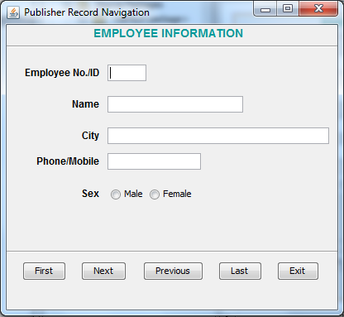

import java.sql.*;
import javax.swing.JOptionPane;

public class EmpNavUI extends javax.swing.JFrame {
/** Creates new form PubNavUI */
public EmpNavUI() {
initComponents();
}
Statement stmt = null;
ResultSet rs = null;
String SQL = "SELECT * FROM emp";
public void disable_textfields() {
txtNo.setEditable(false);
txtName.setEditable(false);
txtAdd.setEditable(false);
txtPh.setEditable(false);

}

private void cmdFirstActionPerformed(java.awt.event.ActionEvent evt) {
try {
Class.forName("com.mysql.jdbc.Driver");
Connection con = (Connection)
DriverManager.getConnection("jdbc:mysql://localhost:3306/test","root","raj");
if (rs.first()) {
String PN = rs.getString("empid");
String PName = rs.getString("empname");
String PAdd = rs.getString("empcity");
String PPh = rs.getString("empphone");
String PSex = rs.getString("empsex");
// Displaying the contents in respective text boxes.
txtNo.setText(PN);
txtName.setText(PName);
txtAdd.setText(PAdd);
txtPh.setText(PPh);
if(PSex.equals("M"))
jRadioButton1.setSelected(true);
else
jRadioButton2.setSelected(true);
cmdFirst.setEnabled(false);
cmdNext.setEnabled(true);
cmdPrev.setEnabled(false);
cmdLast.setEnabled(true);
} else {
cmdFirst.setEnabled(false);
cmdNext.setEnabled(false);
cmdPrev.setEnabled(false);
cmdLast.setEnabled(false);
JOptionPane.showMessageDialog(this, "Rhere is no record in table", "Student",0);
}
} catch (Exception e) {
JOptionPane.showMessageDialog(this, e.getMessage());
}
}

private void cmdNextActionPerformed(java.awt.event.ActionEvent evt) {
try {
Class.forName("com.mysql.jdbc.Driver");
Connection con = (Connection)
DriverManager.getConnection("jdbc:mysql://localhost:3306/test","root","raj");
if (rs.next()) {
String PN = rs.getString("empid");
String PName = rs.getString("empname");
String PAdd = rs.getString("empcity");
String PPh = rs.getString("empphone");
String PSex = rs.getString("empsex");
// Displaying the contents in respective text boxes.
txtNo.setText(PN);
txtName.setText(PName);
txtAdd.setText(PAdd);
txtPh.setText(PPh);
if(PSex.equals("M"))
jRadioButton1.setSelected(true);
else
jRadioButton2.setSelected(true);
cmdFirst.setEnabled(true);
cmdNext.setEnabled(true);
cmdPrev.setEnabled(true);
cmdLast.setEnabled(true);
} else {
cmdNext.setEnabled(false);
JOptionPane.showMessageDialog(this, "You are at last record position", "Student",0);
}
} catch (Exception e) {
JOptionPane.showMessageDialog(this, e.getMessage());
}
}

private void cmdExitActionPerformed(java.awt.event.ActionEvent evt) {
this.setVisible(false);
}

private void cmdPrevActionPerformed(java.awt.event.ActionEvent evt) {
try {

if (rs.previous()) {
String PN = rs.getString("empid");
String PName = rs.getString("empname");
String PAdd = rs.getString("empcity");
String PPh = rs.getString("empphone");
String PSex = rs.getString("empsex");
// Displaying the contents in respective text boxes.
txtNo.setText(PN);
txtName.setText(PName);
txtAdd.setText(PAdd);
txtPh.setText(PPh);
if(PSex.equals("M"))
jRadioButton1.setSelected(true);
else
jRadioButton2.setSelected(true);
cmdFirst.setEnabled(true);
cmdNext.setEnabled(true);
cmdPrev.setEnabled(true);
cmdLast.setEnabled(true);
} else {
cmdPrev.setEnabled(false);
JOptionPane.showMessageDialog(this, "You are at first position", "Student",0);
}
} catch (Exception e) {
JOptionPane.showMessageDialog(this, e.getMessage());
}
}

private void cmdLastActionPerformed(java.awt.event.ActionEvent evt) {
try {
if (rs.last()) {
String PN = rs.getString("empid");
String PName = rs.getString("empname");
String PAdd = rs.getString("empcity");
String PPh = rs.getString("empphone");
String PSex = rs.getString("empsex");
// Displaying the contents in respective text boxes.
txtNo.setText(PN);
txtName.setText(PName);
txtAdd.setText(PAdd);
txtPh.setText(PPh);
if(PSex.equals("M"))
jRadioButton1.setSelected(true);
else
jRadioButton2.setSelected(true);
cmdFirst.setEnabled(true);
cmdNext.setEnabled(false);
cmdPrev.setEnabled(true);
cmdLast.setEnabled(false);
} else {
JOptionPane.showMessageDialog(this, "You are already at last record", "Student",0);
}
} catch (Exception e) {
JOptionPane.showMessageDialog(this, e.getMessage());
}
}

private void formWindowGainedFocus(java.awt.event.WindowEvent evt) {
disable_textfields();
try {
Class.forName("com.mysql.jdbc.Driver");
Connection con = (Connection)
DriverManager.getConnection("jdbc:mysql://localhost:3306/test","root","raj");
stmt = con.createStatement();
rs = stmt.executeQuery(SQL);
if (rs.first())
{
String PN = rs.getString("empid");
String PName = rs.getString("empname");
String PAdd = rs.getString("empcity");
String PPh = rs.getString("empphone");
String PSex = rs.getString("empsex");
// Displaying the contents in respective text boxes.
txtNo.setText(PN);
txtName.setText(PName);
txtAdd.setText(PAdd);
txtPh.setText(PPh);
if(PSex.equals("M"))
jRadioButton1.setSelected(true);
else
jRadioButton2.setSelected(true);
cmdFirst.setEnabled(false);
cmdNext.setEnabled(true);
cmdPrev.setEnabled(false);
cmdLast.setEnabled(true);
}
else
{
cmdFirst.setEnabled(false);
cmdNext.setEnabled(false);
cmdPrev.setEnabled(false);
cmdLast.setEnabled(false);
JOptionPane.showMessageDialog(this, "There is no record in table", "Student",0);
}
} catch (Exception e) {
JOptionPane.showMessageDialog(this, e.getMessage());
}
}
public static void main(String args[]) {
java.awt.EventQueue.invokeLater(new Runnable() {
public void run() {
new EmpNavUI().setVisible(true);
}
});
}

// Variables declaration - do not modify
private javax.swing.ButtonGroup buttonGroup1;
private javax.swing.JButton cmdExit;
private javax.swing.JButton cmdFirst;
private javax.swing.JButton cmdLast;
private javax.swing.JButton cmdNext;
private javax.swing.JButton cmdPrev;
private javax.swing.JLabel jLabel1;
private javax.swing.JLabel jLabel2;
private javax.swing.JLabel jLabel3;
private javax.swing.JLabel jLabel4;
private javax.swing.JLabel jLabel6;
private javax.swing.JLabel jLabel7;
private javax.swing.JRadioButton jRadioButton1;
private javax.swing.JRadioButton jRadioButton2;
private javax.swing.JSeparator jSeparator1;
private javax.swing.JSeparator jSeparator2;
private javax.swing.JTextField txtAdd;
private javax.swing.JTextField txtName;
private javax.swing.JTextField txtNo;
private javax.swing.JTextField txtPh;
// End of variables declaration

}

EmpSearchUI.java
import java.sql.*;
import javax.swing.JOptionPane;
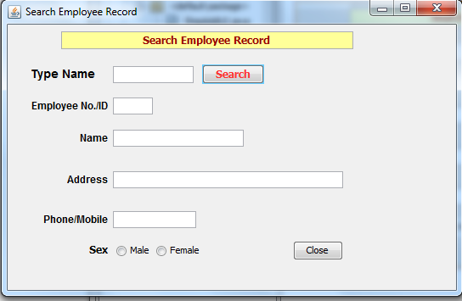
public class EmpSearchUI extends javax.swing.JFrame {
public EmpSearchUI() {
initComponents();
}
Statement stmt = null;
ResultSet rs = null;
private void cmdDeleteActionPerformed(java.awt.event.ActionEvent evt) {
try {
Class.forName("com.mysql.jdbc.Driver");
Connection con = (Connection)
DriverManager.getConnection("jdbc:mysql://localhost:3306/test","root","raj");
String PN =TextSearch.getText().trim();
String SQL = "SELECT * FROM emp WHERE empname like '%"+(PN)+"%'";
stmt = con.createStatement();
rs = stmt.executeQuery(SQL);
if (rs.next()!= rs.isAfterLast()) {
String PID = rs.getString("empID");
String PName = rs.getString("empname");
String PAdd = rs.getString("empcity");
String PPh = rs.getString("empphone");
String PSex = rs.getString("empsex");
// Displaying the contents in respective text boxes.
txtPno.setText(PID);
txtPName.setText(PName);
txtPAdd.setText(PAdd);
txtPh1.setText(PPh);
if (PSex.equals("M"))
jRadioButton1.setSelected(true);
else
jRadioButton2.setSelected(true);
}
else
JOptionPane.showMessageDialog(null,"Search string "+PN+"..not found");
}
catch (Exception e) {
JOptionPane.showMessageDialog(null, e.getMessage()+"Unable to find Record");
}
}
private void cmdExitActionPerformed(java.awt.event.ActionEvent evt) {
this.setVisible(false);
//new MainUI().setVisible(true);
}
// Variables declaration - do not modify
private javax.swing.JTextField TextSearch;
private javax.swing.ButtonGroup buttonGroup1;
private javax.swing.JButton cmdDelete;
private javax.swing.JButton cmdExit;
private javax.swing.JLabel jLabel1;
private javax.swing.JLabel jLabel2;
private javax.swing.JLabel jLabel3;
private javax.swing.JLabel jLabel4;
private javax.swing.JLabel jLabel6;
private javax.swing.JLabel jLabel7;
private javax.swing.JRadioButton jRadioButton1;
private javax.swing.JRadioButton jRadioButton2;
private javax.swing.JTextField jTextField2;
private javax.swing.JTextField txtPAdd;
private javax.swing.JTextField txtPName;
private javax.swing.JTextField txtPh1;
private javax.swing.JTextField txtPno;
// End of variables declaration
}
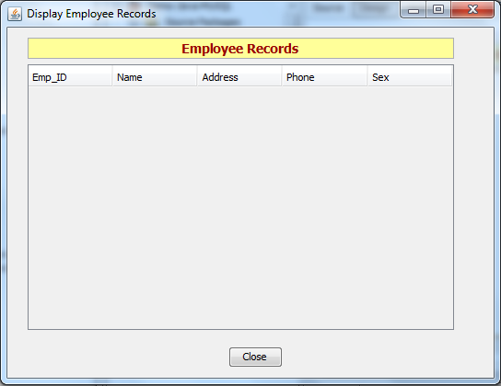
EmpTable.java (Display all records of Emp Table)

import java.sql.*;
import javax.swing.JOptionPane;
import javax.swing.table.DefaultTableModel;
public class EmpTable extends javax.swing.JFrame {
/** Creates new form PubDelUI */
public EmpTable() {
initComponents();
}
private void cmdExitActionPerformed(java.awt.event.ActionEvent evt) {
this.setVisible(false);
//new MainUI().setVisible(true);
}

private void formWindowGainedFocus(java.awt.event.WindowEvent evt) {
DefaultTableModel model = (DefaultTableModel) jTable1.getModel();
// Clear the existing table
int rows = model.getRowCount();
if (rows > 0) {
for (int i = 0; i < rows; i++) {
model.removeRow(0);
}
}
// SQL Query
String query = "SELECT * FROM emp";
try {
Class.forName("com.mysql.jdbc.Driver").newInstance();
Connection con = (Connection) DriverManager.getConnection("jdbc:mysql://localhost:3306/test","root","raj");
Statement stmt = con.createStatement();
ResultSet rs = stmt.executeQuery(query);
// Iterate through the result and display on screen
while (rs.next()) {
String Mno = rs.getString("empId");
String MName = rs.getString("empname");
String MAdd = rs.getString("empcity");
String MPh1 = rs.getString("empphone");
String MDate = rs.getString("empsex");
model.addRow(new Object[] {Mno, MName, MAdd, MPh1, MDate});
}
}
catch (Exception e) {
JOptionPane.showMessageDialog(this, e.getMessage());
}
}
// Variables declaration - do not modify
private javax.swing.ButtonGroup buttonGroup1;
private javax.swing.JButton cmdExit;
private javax.swing.JScrollPane jScrollPane1;
private javax.swing.JTable jTable1;
private javax.swing.JTextField jTextField2;
// End of variables declaration

}

